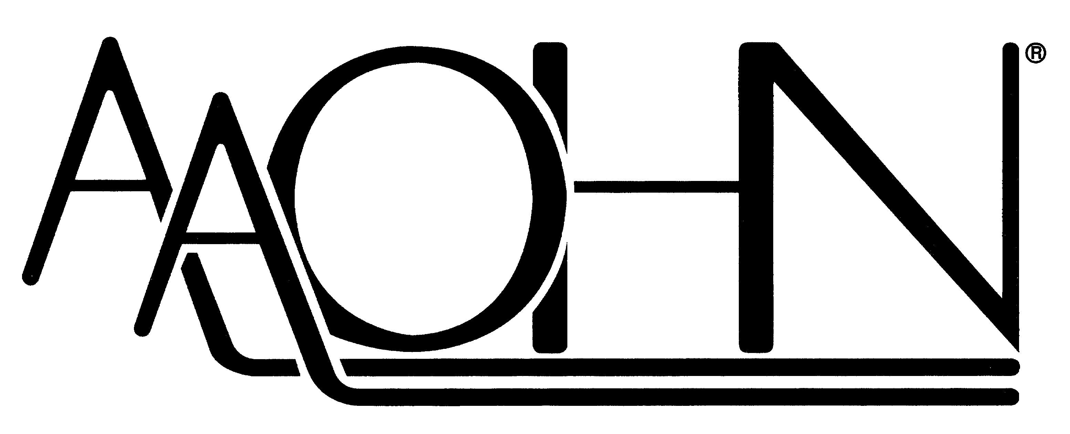
American Association of Occupational Health Nurses, Inc.
330 N Wabash Ave, Suite 2000 | Chicago, IL 60611
Phone: 312-321-5173 | Fax: 312-673-6719
info@aaohn.org | www.aaohn.org

January 1, 2026

Dear Chapter President and Treasurer:

Each year, AAOHN requests chapters complete and return the ACH banking form. Please complete the below form as confirmation of your chapter’s current banking information. The completeness and accuracy of the chapter’s banking details is important for ensuring timely bi-annual payouts of membership dues.
All information received is stored within AAOHN’s secured banking system and will remain confidential.

Please have the Chapter President or Treasurer complete and return the information below. You may return this form electronically by email to info@aaohn.org or by fax to 312-673-6719.

If you have any questions, please contact the National Office at 312-321-5173 or info@aaohn.org

Thank you,
American Association of Occupational Health Nurses
------------------------------------------------------------------------------------------------------------------------------
Chapter Banking Information
------------------------------------------------------------------------------------------------------------------------------
Full Chapter Name________________________________________________________(no abbreviations)

Chapter Address:____________________________________________________________

Treasurer Name & Email (for payment notifications)_______________________________________
President Name & Email (for payment notifications)______________________________

Chapter Name as on the Bank Account:________________________ ____
Bank Name: ______________________________________________ ____________________
Routing Number: ___ ___________________________ ______________________
Account Number: _____ ______________________________________________________
Account Type: □ Checking □ Savings
Signature _ _____________________ Title: _____________

